WEBPACK 5 MODULE FEDERATION

NIPUN S. BHASARKAR

Web App Development CoP

InfoCepts Technologies Pvt. Ltd.

### ***Module federation allows a JavaScript application to dynamically run code from another bundle/build, on both client and server***

## Background

Imagine you and your team are working on a front end application which has a lot of complex sections and pages throughout the application. To build such an application from scratch will take ages for your team to complete it. But what if you add more members to your team? Will it help the development to speed up, or will it create chaos everywhere? Team members stepping on foot of each other, code conflicts and build and deployment wait time. On top of that the code repository will become a huge mono-repo which will be difficult to maintain as time passes by.

To overcome these problems, an architectural concept of Micro Frontends was introduced. The idea of micro frontends is to build different frontends in decoupled codebases, which can be released through separated pipelines and are stitched together to create a cohesive application that feels unified to the user. Micro frontend as an idea has been wandering around the internet since 2015 and it caught pace since late 2018.

There are various ways a micro frontend can be built, and one such way is by using Webpacks module federation.

## What is Module Federation?

Introduced in Webpack 5, the Module Federation gives developers a way to create multiple separate builds that form a single application. Any JavaScript application that is bundled with Webpack 5.0 or greater can dynamically load or share code and dependencies with any other at runtime.

## Why Use Module Federation?

* Better way to share code. Expose any code from any application that Webpack supports.
* Environment-Independent. Use shared code in different environments: web, Node.js etc.
* Resolves Dependency Issues. Federated code defines their dependencies and if Webpack can’t find it in the scope, will download it.

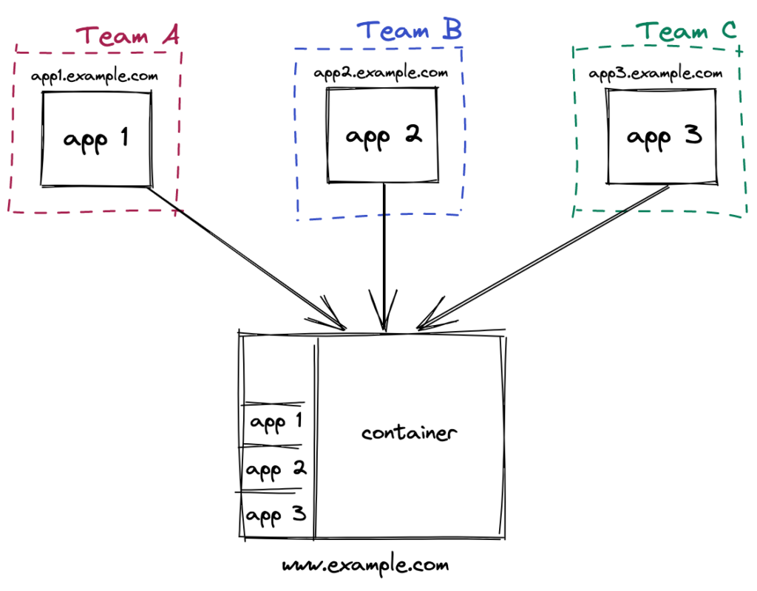*Image: https://cogent.co/blog/deploying-micro-frontends-with-module-federation-and-nextjs/*

## Getting Started

To get started on how to use webpack Module Federation together with the Angular CLI, I have attached a link to Angular Architects github page. The @angular-architects/module-federation plugin is used to make a shell capable of loading a separately compiled and deployed micro frontend.

The key concept is, there is a host app / shell app and one or more micro frontends which are deployed separately, using same or different front end frameworks, into their repository by individual teams. The micro frontends are loaded into the shell app as remote modules.

Follow the tutorial below to get a handson experience. In the tutorial there is one shell app and one micro frontend app for flight details. The MFE app is loaded into the shell app remotely.

All the configurations and webpack configs are explaining in detail here.

<https://github.com/angular-architects/module-federation-plugin/blob/main/libs/mf/tutorial/tutorial.md>

